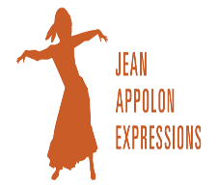
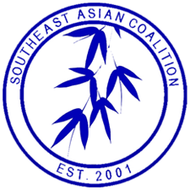
Southeast Asian Coalition of Central Massachusetts
and
Jean Appolon Expressions

October 8, 2023

Dear Friends,

The Southeast Asian Coalition of Central MA (SEACMA), in partnership with Jean Appolon Expressions (JAE) and supported by the Center for Health Impact and Worcester Rise for Health are excited to invite you to our Central MA Refugee Welcoming Event. This Event will take place on Sunday, October 22, 2023 from Noon to 4:00 PM at Seven Hills Foundation located at 81 Hope Ave, Worcester, MA 01603.

SEACMA, founded in 2001, has a long history of supporting Southeast Asian immigrants, refugees and newcomers in overcoming barriers and becoming contributors in the economic, social, and civic life of the community in which they reside. Jean Appolon Expressions (JAE) is a contemporary dance company deeply rooted in Haitian-folkloric culture that celebrates, nurtures, and empowers a global community. JAE accomplishes this through professional performances, teaching, and fostering healing and the joy of movement in people of all ages, abilities, and backgrounds to contribute to a socially just world. JAE will be leading Haitian Folkloric dance and drumming classes, along with literacy experiences for the families.

We will be providing culturally relevant food and transportation so that the families can participate in the event. We also hope that employers who are hiring will be available to provide information about job resources. We are also seeking professionals who can provide health, immigration and other relevant resources. Additionally, if you speak Haitian Creole and would like to help out, please consider volunteering. We also need volunteers to help with multiple activities that will take place at the event.

We are looking for sponsors and volunteers. If you wish to participate as a sponsor or a volunteer, please complete the form below. We are grateful for your support and we hope to see you at the Central MA Refugee Welcoming Event on Sunday, October 22nd.

With Warmest Regards,

Tuyet Tran, Executive Director (SEACMA)
Meg McGrath Executive Director (JAE)
Jean Appolon, Artistic Director (JAE)

Southeast Asian Coalition of Central MA
and Jean Appolon Expressions

Sponsors Pledge Form
(Email form to events@seacma.org)

Please use this form to indicate your contribution and support of our Central MA Refugee Welcoming Event on Sunday October 22, 2023.

Name:
______________________________________________________________________

Company: ______________________________________________________________________

Address: ______________________________________________________________________

Email:
_______________________________________________________________________

Telephone:
_______________________________________________________________________

Table: _________Yes _________No (Please be aware that space is limited. We will be prioritizing job, legal and health resource tables).

Please make checks payable to: Southeast Asian Coalition of Central MA or go to www.seacma.org for payment thought PAYPAL.

Mail check to: 50 Portland St. Suite 521 Worcester, MA 01608
Southeast Asian Coalition’s tax exemption number: 04-3393955.
For more information, please contact us at our email: Events@seacma.org

Southeast Asian Coalition of Central MA
and Jean Appolon Expressions

Volunteer Form

Please Email form to Events@seacma.org

Name:
______________________________________________________________________

Company: ______________________________________________________________________

Address: ______________________________________________________________________

Email:
_______________________________________________________________________

Telephone:
_______________________________________________________________________

What is the best Way to Contact you?

What would you like to help with?

Do you speak Haitian Creole?

How did you hear about this event?

Thank you!!!

